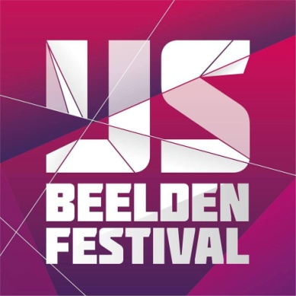

- Press Release -

-Dutch Ice Sculpture Festival 2022
“WHAT A WONDERFUL WORLD”

From 17 December 2022 to 5 March 2023, the largest ice sculpture festival in Europe will take place in Zwolle again. The Dutch Ice Sculpture Festival has grown into the largest winter event of the Netherlands.
This year, the Dutch Ice Sculpture Festival wants to inspire with the theme: “WHAT A WONDERFUL WORLD”. After a long time of Corona insecurity, fear, and loneliness, it is time again to enjoy the beautiful things in life together. We have changed as human beings. We have gained more admiration and respect for the world through Covid-19. More awareness has arisen because of the things that we could not do for a long time. The desire for travel, being abroad, entertainment and doing fun things together has never been greater than now. We have learned that many things cannot be taken for granted, we want to embrace the world again. The Ice Sculpture Festival wants to show how beautiful the world is: “WHAT A WONDERFUL WORLD”.
The best ice artists from all over the world will come to Zwolle, where they will work in a 1,200 m² cold hall with 550,000 kilos of ice and snow. In doing so, they will translate the theme “WHAT A WONDERFUL WORLD” into ice and snow sculptures of up to 6 meters high. Special effects with light, sound and decoration will make the images even more magical.
In the Jägermeister ice bar, you can warm up your inner person again, but you can also use the heated hospitality terraces to enjoy a hot chocolate with whipped cream and a piece of apple strudel.
After your visit to the Dutch Ice Sculpture Festival, you can take a bus you to the beautiful vibrant city centre of Zwolle free of charge. You can leave your car in the IJsselhallen car park, the bus will also take you back for free. The Hanseatic city of Zwolle has a lot to offer its visitors: it is a city with a rich history, quaint shopping streets, wonderful museums and atmospheric restaurants and cafes. A city more than worthwhile to be discovered!

-------------------------------------------------------------------------------------------------------------------------

General information Dutch Ice Sculpture festival 2022/2023:
Date: 17 December 2022 to 5 March 2023
Location: IJsselhallen, Rieteweg 4, 8011 AB Zwolle, The Netherlands
IJsselhallen is within walking distance of the train station.
Opening hours: Open every day from 10:00 a.m. to 5:00 p.m. Also open on Mondays during the Christmas and spring holidays. Closed on Mondays outside the Christmas and spring holidays.
1 January 2023: closed
Website: www.ijsbeelden.nl
Ticket sales through the website: www.ijsbeelden.nl/en
Target group: from 4 years to 99 years
Ice Sculpture Festival is wheelchair-friendly
IJsselhallen offers plenty of parking space
More information can be requested from: info@ijsbeelden.nl
Contact: Eric Broekaart/ eric@organisatieteam.nl

